**INTODUCTION**

Urban Aura Interiors is a dynamic and innovative interior design firm that has made a significant mark in the world of urban design. Founded with a passion for transforming spaces into unique, functional, and aesthetically pleasing environments, Urban Aura Interiors has established itself as a go-to choice for individuals and businesses looking to elevate their interior spaces.

With a commitment to creating interiors that reflect the personality, lifestyle, and needs of their clients, Urban Aura Interiors has earned a reputation for its creative vision, attention to detail, and dedication to excellence. The firm brings a contemporary and sophisticated approach to interior design, with a focus on crafting spaces that not only look stunning but also enhance the overall quality of life within them.

Urban Aura Interiors understands the ever-evolving nature of urban living, where space is often limited, and the demands for functionality and style are high. Their design solutions are tailored to address these challenges, ensuring that each project not only meets but exceeds the expectations of their clients.

Whether it's residential, commercial, or hospitality projects, Urban Aura Interiors brings a wealth of experience and a fresh perspective to every design endeavor. Their work is characterized by a balance of modern aesthetics, practicality, and a keen sense of the latest design trends.

In an urban world where individuality and personal expression are highly valued, Urban Aura Interiors stands out for its ability to translate the unique aspirations of its clients into beautifully designed, urban living spaces. They continue to shape the urban landscape with their creative designs and remain at the forefront of the interior design industry

**PURPOSE.**

The purpose of using Urban Aura Interiors in interior design projects is to achieve a variety of objectives that enhance the functionality, aesthetics, and overall experience of a space. Here are some of the key purposes and what can be achieved through their services:

1. Enhanced Aesthetics: Urban Aura Interiors specializes in creating visually appealing interior designs. They can transform a bland or outdated space into a visually stunning and harmonious environment. Through the selection of colors, materials, furnishings, and decorative elements, they can achieve a cohesive and stylish aesthetic that aligns with the client's preferences and the latest design trends.

2. Optimized Space Utilization: Urban living often comes with limited space, and this firm can maximize the use of available square footage. Through intelligent space planning, clever storage solutions, and a keen understanding of traffic flow, they can make even small spaces feel more open and functional.

3. Personalization: One of the primary purposes of using Urban Aura Interiors is to create personalized interiors. They work closely with clients to understand their lifestyle, tastes, and specific needs. This results in spaces that reflect the individuality and personality of the client, making it a truly unique and comfortable environment.

4. Functionality: A well-designed interior is not just about looks; it's also about functionality. Urban Aura Interiors can enhance the practicality of a space, making it more convenient and efficient for its intended use. This is especially important in commercial and hospitality projects, where user experience and operational efficiency are critical.

5. Atmosphere and Mood: Depending on the project and client's goals, Urban Aura Interiors can create different atmospheres and moods within a space. Whether it's a cozy, warm atmosphere for a residential setting or a vibrant, dynamic one for a commercial space, they use elements such as lighting, color schemes, and decor to set the desired tone.

6. Increased Property Value: For homeowners and property investors, using Urban Aura Interiors can lead to an increase in property value. Well-designed interiors can make a property more attractive to potential buyers or renters, resulting in higher market value.

**PROBLEM DEFINITION & DESINGN THINKING**

1.1Empathy map

1.Say: "We want to deliver personalized and innovative design solutions."

2. Think: "We need to understand the client's vision and expectations to create a unique and tailored design."

3. Do: - Conduct in-depth client interviews to understand their needs and style preferences.

- Collaborate with clients to develop mood boards and design concepts.

- Present design proposals and options.

4. Feel: - Motivated to bring clients' dreams to life.

- Empathetic towards clients' concerns and anxieties.

- Focused on delivering top-notch design while respecting budget constraints.

- Dedicated to open and clear communication with clients.

Top of Form

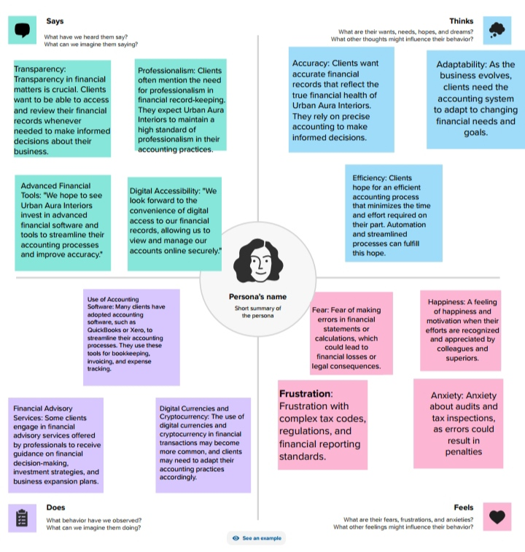

* 1. Ideation & Brainstorming Map:

**1.Characteristics**

* + Aesthetic appeal
  + Use of space
  + Integration of nature

2.Accounts

* + Interviews with interior designers
  + Case studies of urban interiors
  + Urban explorations

3.Timeline

* + Short-term goals
  + Long-term goals
  + Milestones

4.Feedback and Iteration

* + Gather feedback
  + Revise and refine ideas
  + Stay up-to-date with trendsTop of Form

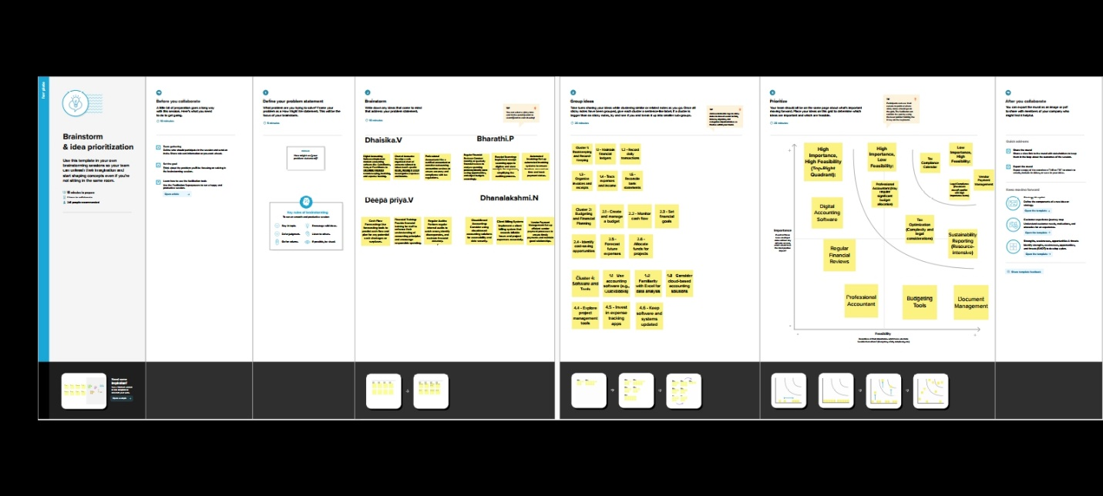

**RESULT:**

Final findings (output) of the project:

1. Transformed Living Spaces: Urban Aura Interiors will have successfully transformed the interiors of various residential or commercial spaces, turning them into aesthetically pleasing, functional, and comfortable environments.

2. Customized Design Solutions: Each project will reflect a unique and personalized design approach that aligns with the client's needs, style preferences, and vision.

3. Enhanced Aesthetics: The designed spaces will exhibit improved aesthetics, featuring harmonious color schemes, stylish furnishings, and carefully selected decor elements.

4. Improved Functionality: Urban Aura's design solutions will have optimized the functionality of interior spaces, making them more practical and efficient for daily use.

5. Increased Property Value: For residential clients, the well-designed interiors can potentially lead to an increase in the resale value of their homes. For commercial clients, it can improve the attractiveness of their space to customers or clients.

6. Sustainability and Eco-friendliness: If sustainability was a focus, the designs may incorporate eco-friendly materials and practices, contributing to a more environmentally responsible interior.

**PROFIT & LOSS A/C AND BALANCE SHEET BELOW**

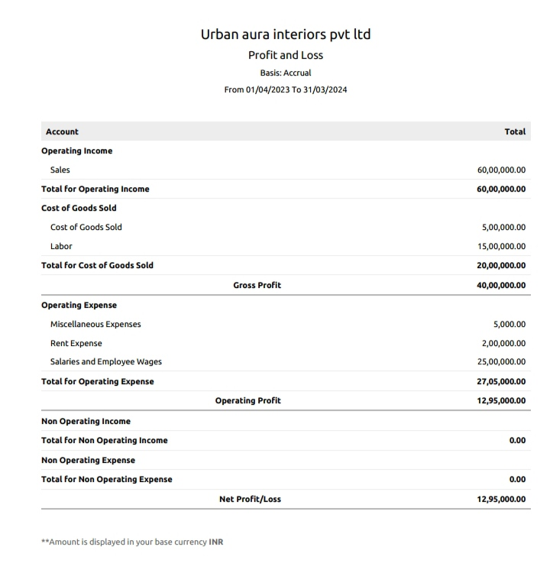

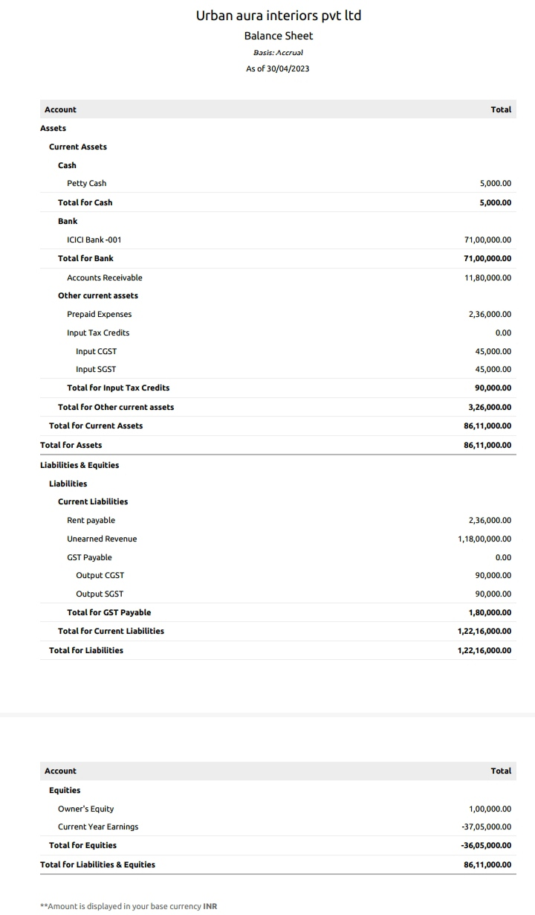

**ADVANTAGES:**

1. **Expense Control**: It allows a company to track and analyze its expenses, which is crucial for managing costs and improving profitability.
2. **Decision-Making**: Management can use P&L statements to make informed decisions about pricing, product lines, and investment in various areas of the business.

3. **Investor and Stakeholder Communication**: P&L statements are often used to communicate a company's financial performance to investors, stakeholders, and potential lenders.

**4.Tax Reporting**: Businesses use P&L statements to calculate their taxable income, which is essential for complying with tax regulations.

5. **Long-Term Financial Health**: The balance sheet provides an overview of a company's financial position at a specific point in time, including assets, liabilities, and equity. It helps assess the company's long-term financial health.

**6.Debt and Equity Analysis**: Investors and creditors can use balance sheets to evaluate a company's debt levels and the proportion of equity, which is crucial for risk assessment.

**7.Liquidity Assessment**: The balance sheet helps in determining the liquidity of a company by showing the relationship between current assets and current liabilities.

**8.Asset Valuation**: It provides information about the value of a company's assets, which is essential for decision-making regarding asset management and acquisitions

**DISADVANTAGES:**

1. **Short-Term Focus**: P&L statements primarily focus on short-term financial performance and may not reflect the long-term financial health of a company.
2. **Doesn't Account for Non-Cash Items**: P&L statements do not consider non-cash items like depreciation and amortization, which can affect a company's cash flow.
3. **Subject to Manipulation**: Companies can sometimes manipulate their P&L statements by deferring or accelerating revenues or expenses to make their financial performance appear more favorable.

4.**Static View**: Balance sheets provide a snapshot of financial data at a specific moment and do not reflect changes or trends over time.

5.**Complex Accounting Rules**: The valuation of certain assets and liabilities on the balance sheet can be complex, involving various accounting rules and estimates.

6**.Limited Information**: Balance sheets alone do not provide insights into a company's income, cash flow, or operational performance.

**APPLICATIONS:**

1. **QuickBooks:** QuickBooks is a widely used accounting software that offers tools for creating P&L statements and balance sheets. It is suitable for small and medium-sized businesses.
2. **Xero:** Xero is another cloud-based accounting software that provides P&L and balance sheet capabilities. It is popular among small businesses and accountants.
3. **FreshBooks:** FreshBooks is designed for small businesses and freelancers. It simplifies the process of creating financial reports, including P&L and balance sheets.
4. **Zoho Books:** Zoho Books is part of the Zoho suite of business tools. It offers accounting and financial reporting features, including P&L and balance sheets.
5. **Wave:** Wave is a free accounting software designed for small businesses. It can generate financial reports, including P&L statements and balance sheets.
6. **Sage 50 (formerly Peachtree):** Sage 50 is a robust accounting software used by medium-sized businesses. It offers advanced financial reporting and analysis features.
7. **Microsoft Excel:** Many businesses use Microsoft Excel for financial reporting. You can create custom P&L and balance sheet templates or use pre-designed templates available in Excel.
8. **Google Sheets:** Google Sheets is a free cloud-based spreadsheet tool that can be used for creating financial statements. It offers collaboration features as well.
9. **Tally ERP 9:** Tally ERP 9 is widely used in India and other countries. It's known for its accounting and financial reporting capabilities.

**10.SAP Business One:** SAP Business One is an enterprise-level ERP system that includes robust financial reporting and accounting features.

**11.Accounting Software Customized for Specific Industries:** Some industries have specialized accounting software that includes features for P&L and balance sheets. For example, property management software or restaurant management software may have tailored solutions.

**CONCLUTION:**

1. **Accuracy and Compliance:** The foremost consideration is ensuring the accuracy of the financial records. All transactions should be recorded correctly and in compliance with accounting standards and regulations relevant to the business's location and industry.
2. **Profit and Loss (P&L) Statement:** The P&L statement summarizes the revenue and expenses over a specific period (usually a fiscal year). The conclusion of preparing this statement helps to assess the profitability of Urban Aura Interiors during that time frame.
3. **Balance Sheet:** The balance sheet provides an overview of the company's financial position at a specific point in time. It includes assets, liabilities, and shareholders' equity. This document helps evaluate the company's solvency and overall financial health.
4. **Cash Flow Statement:** Preparing a cash flow statement is essential to understand how cash moves in and out of the business. It is crucial for managing liquidity and ensuring that the company can meet its financial obligations.
5. **Financial Analysis:** The conclusion of preparing accounts often involves a thorough analysis of the financial statements. This analysis can identify trends, strengths, weaknesses, and areas for improvement in the company's financial performance.
6. **Tax Compliance:** Ensuring that all tax-related documentation and calculations are accurate and in compliance with local tax laws is a crucial aspect of preparing accounts.
7. **Management Insights:** The financial statements and accounts offer valuable insights for management and stakeholders. These insights can be used for decision-making, setting financial goals, and planning for the future.
8. **Auditing and Review:** Depending on the company's size and regulatory requirements, there may be a need for an external audit or internal review of the financial accounts to provide an additional layer of assurance regarding their accuracy and compliance.
9. **Financial Reporting:** The prepared accounts are used for internal reporting to management and external reporting to stakeholders, such as investors, creditors, and regulatory authorities.

In conclusion, preparing the accounts for Urban Aura Interiors that provides a clear picture of the company's financial performance and position. It plays a crucial role in decision-making, financial planning, and regulatory compliance. It's essential to ensure accuracy, compliance with relevant regulations, and use the financial information to drive the business forward.

Top of Form

**FUTURE SCOPE:**

1. **Diversification of Services:** Expanding the range of interior design services offered can be a key growth strategy. This might include services such as home staging, virtual design consultations, or sustainable design solutions.
2. **Specialization:** Focusing on a specific niche within interior design, such as commercial spaces, healthcare facilities, or sustainable design, can lead to specialization and growth opportunities.
3. **Sustainability:** With increasing environmental awareness, there is a growing demand for sustainable and eco-friendly interior design solutions. Urban Aura Interiors can explore sustainable design practices and materials to meet this demand.
4. **Technological Integration:** Incorporating technology like 3D modeling, virtual reality, and augmented reality for design visualization can enhance the client experience and set the business apart.
5. **Online Presence:** Building a strong online presence, including a professional website and active social media profiles, can help attract clients and showcase the company's portfolio.
6. **Collaborations and Partnerships:** Collaborating with architects, real estate agents, or furniture manufacturers can expand opportunities and lead to a broader client base.
7. **Global Reach:** With the help of digital tools and remote working capabilities, Urban Aura Interiors can potentially tap into international markets.
8. **Continued Education:** Keeping the team updated with the latest design trends, materials, and technologies is crucial for staying competitive in the industry.
9. **Client Relationships:** Building and maintaining strong client relationships can lead to repeat business and referrals, which are essential for long-term success.
10. **Regulatory Compliance:** Keeping up with building codes, safety regulations, and other legal requirements is critical in ensuring that the business can operate smoothly.
11. **Market Research:** Continuously monitoring market trends and customer preferences will help Urban Aura Interiors adapt to changing demands and stay relevant.
12. **Employee Development:** Investing in the skills and development of the team members can lead to better service and client satisfaction.
13. **Brand Building:** Developing a strong and recognizable brand can help Urban Aura Interiors stand out in a competitive market.

The future scope of Urban Aura Interiors, will depend on its ability to adapt to changing market conditions and to offer innovative, high-quality services that meet the needs and preferences of its clients. Staying informed about industry trends and continuously improving the business's offerings are key to long-term success.

Top of Form

Top of Form